SCILLSS Classroom Science Assessment Workshop

# Grade 5 Sample Task Ideas

|  |
| --- |
| **NGSS PE: 5-ESS1-2.** Represent data in graphical displays to reveal patterns of daily changes in the length and direction of shadows, day and night, and the seasonal appearance of some stars in the night sky. |

# Example Task Ideas

1. As part of a fifth-grade science project, students recorded the position of the sun in the sky and the position of the shadow of a tree at different times of the day. The students stood in the same location, directly north of the tree, for each observation. The students forgot to collect the data at 3 p.m. The drawings the students produced are shown in Figure 1.

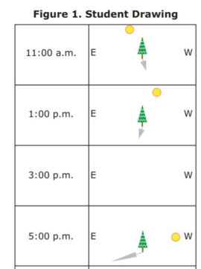

* 1. If the students had completed their drawing at 3 p.m., what would it have looked like?
  2. The students decide to make a graph to show the relationship between the apparent position of the sun in the sky and the length of the tree shadow. Answer the following to describe how you would complete this task.
     1. Describe your graph and how you would label it.
     2. What pattern would your graph show?

1. Students can develop and use a model to demonstrate that the rotation of Earth on its axis between its North and South poles causes night and day.
2. Students can analyze data from observations to reveal patterns in shadows.
3. Students can represent data in a graph or table to determine the patterns in the changes of shadows over time.
4. Students can explain from evidence that patterns in the length and direction of shadows are due to the rotation of Earth on its axis between the North and South poles.
5. Students can chart lunar phases to reveal that the changing phases of the moon occur in a monthly cyclical pattern.
6. Students can develop a model to explain that the changing monthly cyclical phases of the moon are due to the orbit of the moon around Earth.
7. Students can plan and carry out investigations to show that the revolution of the Earth around the sun causes predictable seasonal changes.
8. Students can analyze and interpret data to develop an understanding that as the seasons change, so do the observable positions of the stars depending on the day, month, and year.

The Grade 5 Sample Task Ideas were developed with funding from the US Department of Education under Enhanced Assessment Grants Program CFDA 84.368A. The contents do not necessarily represent the policy of the US Department of Education, and no assumption of endorsement by the Federal government should be made.   
  
All rights reserved. Any or all portions of this document may be reproduced and distributed without prior permission, provided the source is cited as: Strengthening Claims-based Interpretations and Uses of Local and Large-scale Science Assessment Scores Project (SCILLSS). (2020). *SCILLSS Classroom Science Assessment Workshop: Grade 5 Sample Task Ideas*. Lincoln, NE: Nebraska Department of Education.