SCILLSS Classroom Science Assessment Workshop

**Illustration of Task Features Informed by the Unpacking and Task Specifications Tools**

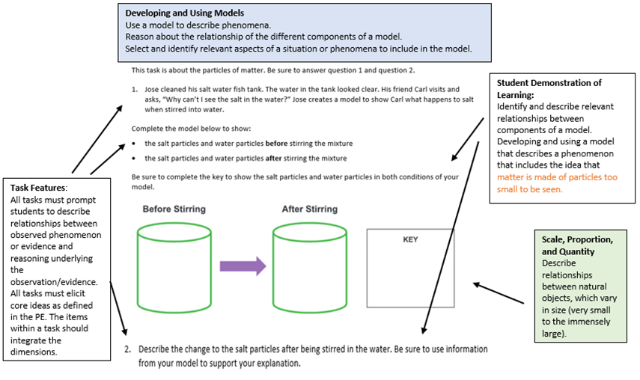

The Illustration of Task Features Informed by the Unpacking and Task Specifications Tool was developed with funding from the US Department of Education under Enhanced Assessment Grants Program CFDA 84.368A. The contents do not necessarily represent the policy of the US Department of Education, and no assumption of endorsement by the Federal government should be made.   
  
All rights reserved. Any or all portions of this document may be reproduced and distributed without prior permission, provided the source is cited as: Strengthening Claims-based Interpretations and Uses of Local and Large-scale Science Assessment Scores Project (SCILLSS). (2020). *SCILLSS Classroom Science Assessment Workshop: Illustration of Task Features Informed by the Unpacking and Task Specifications Tool*. Lincoln, NE: Nebraska Department of Education.